Understanding Passenger Survival Patterns on the Titanic Through Data Visualization
Week 2 data storytelling report

Prepared by: Sanket Udaykumar Sutar
Submission date: 6 Aug 2026

Table of Contents

1. Introduction
2. Objective
3. Dataset Overview
4. Methodology
5. Data Storytelling
6. Visualization 1: Passenger Class Distribution
7. Visualization 2: Survival by Gender
8. Visualization 3: Survival by Passenger Class
9. Visualization 4: Age Distribution by Survival
10. Visualization 5: Fare by Passenger Class
11. Business and Scientific Implications
12. Conclusion
13. References

1. Introduction
The Titanic dataset provides a compact but powerful setting for learning how demographic and socioeconomic characteristics can be translated into an evidence-based story. Rather than presenting isolated charts, this report follows a sequence: first describing who was on board, then examining who survived, and finally considering which passenger characteristics were associated with different outcomes.
The analysis should be interpreted as an exploratory description of this historical dataset—not as proof that any single characteristic caused survival or death. The observed outcome reflects multiple interacting factors, including evacuation decisions, ship layout, access, timing, family circumstances, and chance.

2. Objective
The objective is to use five visualizations to explain passenger composition and identify visible survival patterns by gender, passenger class, age, and fare. The report is designed for a non-technical audience: each chart is positioned as evidence in a narrative, with the explanation focusing on what the audience should notice and why it matters.

3. Dataset Overview
The cleaned file, Titanic_Cleaned.csv, is the analytical source for this report. The expected structure includes one row per passenger and variables such as Survived, Pclass, Sex, Age, Fare, and—where retained—family and embarkation fields. In the commonly used 891-record passenger sample, Survived is coded 0 for did not survive and 1 for survived; confirm the final row count and coding in the cleaned file before submission.
Data-quality note: Age may contain missing values in the original dataset. The age visualization therefore reflects the available age records unless the cleaning process used imputation. Fare can also be influenced by shared tickets, so it should be treated as an indicator of ticket-level economic position rather than a complete measure of personal wealth.

4. Methodology
The analysis uses pandas to load the cleaned data and Seaborn/Matplotlib to create descriptive charts. Count plots are used for categorical comparisons, a histogram is used to compare age distributions, and a boxplot is used to show the spread of fares across passenger classes.
- Load Titanic_Cleaned.csv and inspect columns, data types, missing values, and outcome coding.
- Use consistent labels: Survived = 1 means survived; Survived = 0 means did not survive.
- Read the charts in sequence, moving from population context to outcome differences and then to economic interpretation.
- Avoid causal language: use “associated with,” “linked to,” or “suggests” rather than “caused.”

5. Data Storytelling
The story begins with the passenger mix. The class distribution establishes that the dataset contains passengers from different economic backgrounds, making class a meaningful comparison variable. The next charts show that survival was not evenly distributed: gender and class separate the outcomes visibly, while age adds a demographic layer to the explanation.
The final chart connects fare to class. This does not independently explain survival, but it helps the audience understand why class can represent unequal access, location, services, and movement through the ship. The overall lesson is that the survival outcome should be examined through several dimensions together, not through a single ranking of passengers.

6. Visualization 1: Passenger Class Distribution
plt.figure(figsize=(10,6))
sns.countplot(x="Pclass", data=df, palette="Set2", linewidth=2)
plt.title("Distribution of Passengers Across Ticket Classes")
plt.xlabel("Passenger Class")
plt.ylabel("Number of Passengers")
plt.legend(title="Passenger Class", labels=["1st Class", "2nd Class", "3rd Class"])
plt.show()
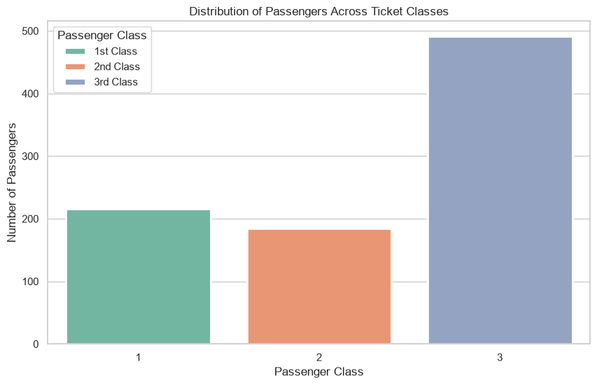 This opening chart answers the question: “Who were the passengers represented in the dataset?” It shows how many observations belong to first, second, and third class, creating a baseline for the rest of the analysis.
Class is more than a label in this story: it provides context about differences in ticket level and likely economic position. The audience should retain the composition of the passenger population before interpreting survival comparisons; a group’s size affects how its counts appear in later charts.
Presenter cue: This is a descriptive starting point, not yet a survival conclusion.

7. Visualization 2: Survival by Gender
plt.figure(figsize=(10,6))
sns.countplot(x="Sex", hue="Survived", data=df, palette="Set1", linewidth=2)
plt.title("Survival Rate by Gender", fontsize=18, weight="bold")
plt.xlabel("Gender", fontsize=13)
plt.ylabel("Passenger Count", fontsize=13)
plt.legend(title="Survived", labels=["No", "Yes"])
plt.show()
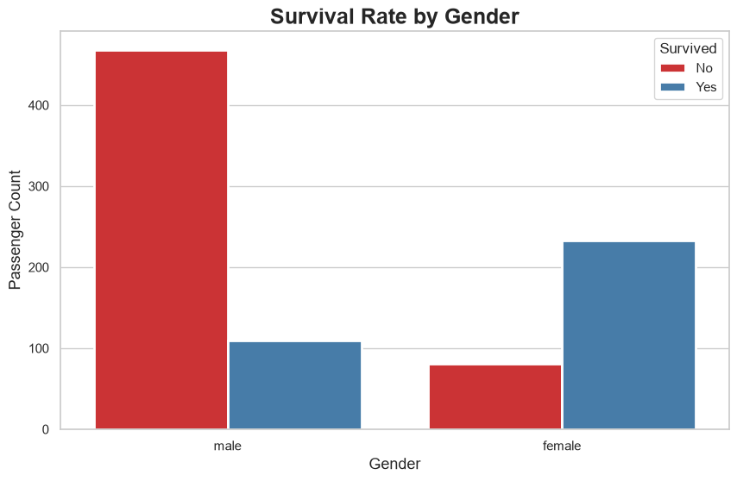 This chart shifts the story from passenger composition to outcomes. The visible contrast between women and men indicates that survival was strongly associated with gender in the dataset, with women representing a larger share of survivors relative to their group size.
The pattern is consistent with the historical evacuation convention commonly summarized as “women and children first,” but the chart itself shows association rather than the complete mechanism. Use rates—not only raw counts—when presenting the finding, because the number of men and women in the dataset may differ.
Presenter cue: Lead-in sentence for presentation: “After asking who was on board, we now ask whether survival was distributed equally across passengers.”

8. Visualization 3: Survival by Passenger Class
plt.figure(figsize=(10,6))
sns.countplot(x="Pclass", hue="Survived", data=df, palette="Set2", linewidth=2)
plt.title("Survival Rate by Passenger Class", fontsize=18, weight="bold")
plt.xlabel("Passenger Class", fontsize=13)
plt.ylabel("Passenger Count", fontsize=13)
plt.legend(title="Survived", labels=["No", "Yes"])
plt.show()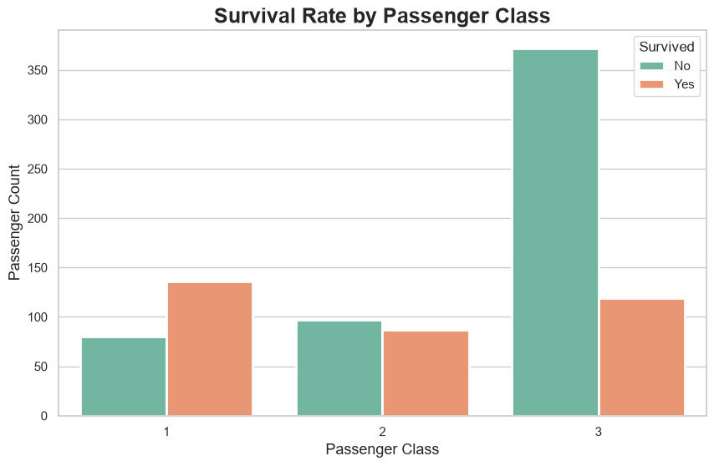
This chart examines whether ticket class was associated with survival. The expected pattern is a more favorable survival outcome for first-class passengers and a less favorable outcome for third-class passengers, with second class positioned between them; the exact difference should be read from the inserted chart.
The pattern suggests that social and economic position may have shaped access to information, routes, lifeboats, and evacuation time. It should not be presented as a simple rule for every individual: some lower-class passengers survived and some first-class passengers did not.
Presenter cue: The key message is unequal survival across groups, not certainty of survival for any class.

9. Visualization 4: Age Distribution by Survival
plt.figure(figsize=(10,6))
sns.histplot(data=df, x="Age", hue="Survived", bins=25, kde=True, palette="Set1", alpha=0.6)
plt.title("Age Distribution by Survival Status", fontsize=18, weight="bold")
plt.xlabel("Age", fontsize=13)
plt.ylabel("Frequency", fontsize=13)
plt.legend(title="Survived", labels=["No", "Yes"])
plt.show()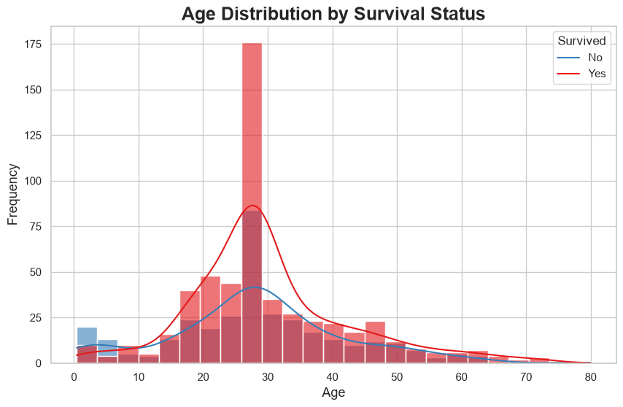 This histogram compares the ages of survivors and non-survivors. It helps the audience see whether survivors were concentrated in particular age ranges and whether children or older passengers appear differently represented in the two outcome groups.
Age is best described as a supporting factor rather than an isolated explanation. Its apparent influence may overlap with gender, class, family relationships, and evacuation priority, so the chart should be used to identify patterns for further investigation—not to claim that age alone determined the outcome.
Presenter cue: If the distributions overlap substantially, state that age differentiates the groups less clearly than gender or class in this dataset.

10. Visualization 5: Fare by Passenger Class
sns.set_theme(style="whitegrid")
plt.figure(figsize=(10,6))
sns.boxplot(x="Pclass", y="Fare", data=df, palette="Set2", linewidth=2, fliersize=6)
plt.title("Ticket Fare by Passenger Class", fontsize=18, weight="bold")
plt.xlabel("Passenger Class", fontsize=13)
plt.ylabel("Ticket Fare", fontsize=13)
plt.legend(title="Passenger Class", labels=["1st Class", "2nd Class", "3rd Class"])
plt.show()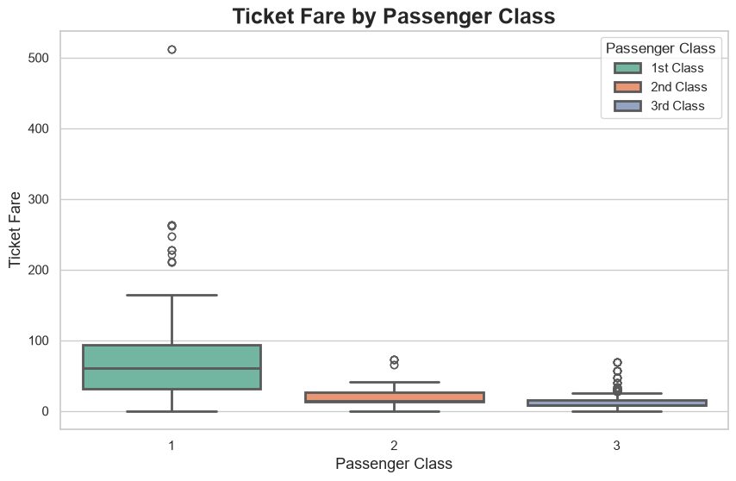
This chart explains the economic context behind passenger class by showing the distribution of ticket fares within each class. Higher fares are generally associated with higher classes, while the boxplot also reveals variation and possible outliers within classes.
Fare reinforces the interpretation that passengers did not experience the voyage under identical economic conditions. However, fare is not a direct measure of personal wealth or physical access to a lifeboat; shared tickets, cabin arrangements, and other operational factors can affect its meaning.
Presenter cue: This is the bridge from “class differences” to the broader lesson about unequal conditions and access.

11. Business and Scientific Implications
Although the Titanic is a historical case, the analytical lesson is relevant to risk, safety, and service design. When outcomes differ systematically between groups, decision-makers should examine whether resources, information, access, or procedures are distributed equitably.
- Passenger class is associated with survival probability and can be used as a proxy for unequal socioeconomic conditions.
- Gender shows a strong difference in evacuation outcomes in this dataset; such differences should be investigated alongside policy, procedure, and context.
- Age adds demographic context, but its effect should be evaluated together with gender, class, and family-related variables.
- Fare helps communicate economic segmentation, but it should not be treated as a causal variable without additional evidence.
- Data visualization makes group disparities understandable to non-technical decision-makers and helps direct deeper statistical analysis.
Scientific caution: these charts are univariate or two-variable exploratory views. A stronger follow-up would use cross-tabulated survival rates and a multivariable model to test whether class, gender, and age retain distinct associations after accounting for one another.

12. Conclusion
The visual narrative moves from “who was represented” to “who survived” and then to “what characteristics were associated with the difference.” The strongest story is that survival was unevenly distributed, with gender and passenger class providing the clearest contrasts, age adding demographic context, and fare helping explain the socioeconomic structure behind class.

13. References
- Titanic dataset.
- Titanic_Cleaned.csv,created for this analysis.

